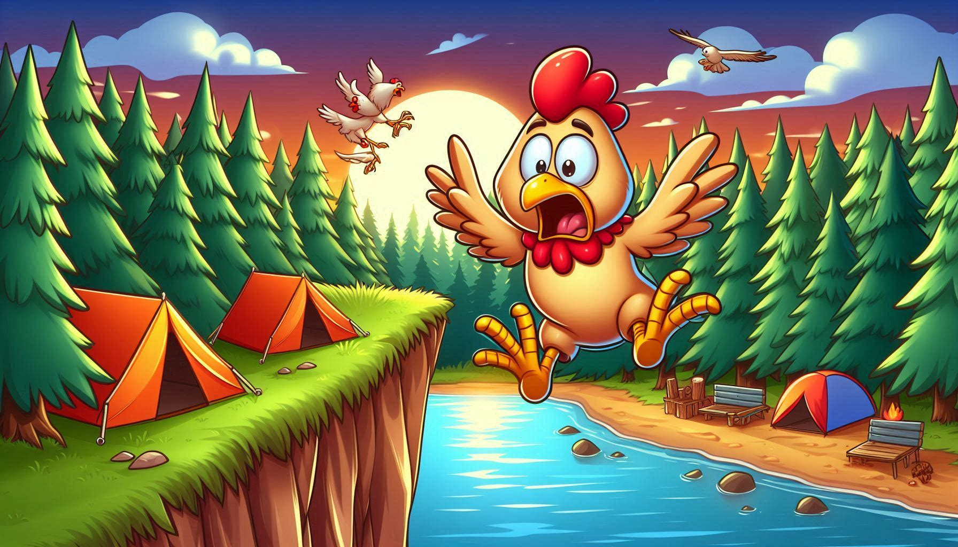

**26th Annual**

**CHICKEN ROCK CAMPOUT 2025**

**SEPTEMBER 12th-14th 2025**

**Location:**

**Stockton State Park, Mutton Group Campground**

**AKA – Chicken Rock (NOT Marina)**

**FRIDAY – SEPT. 12TH**

**● 12pm - Check In**

**● 2pm - Topic Meeting (sign up in welcome tent to host a meeting)**

**● 3:30pm - Topic Meeting**

**● 6pm - ** Chili Supper Potluck**

**● 7pm - *Speaker Meeting:***

***Paul S, Mt Vernon, Mo, Came to Believe***

**SATURDAY – SEPT. 13TH**

**● 8am - Topic Meeting**

**● 9:30am - Topic Meeting**

**● 10am AL-ANON Meeting**

**● 11am - Topic Meeting**

**● 12-1pm - **POTLUCK LUNCH - hot dogs and buns provided**

**● 1:30pm - AA Skit**

**● 3pm - Raffle Drawing**

**● 6pm - **POTLUCK DINNER – pulled pork and buns provided**

***\*\*Please bring a side dish for potluck meals (you are responsible for your breakfast and drinks)***

**● 7pm - Sobriety Countdown, Coins & Speaker Meeting:**

***Laurie C, Springfield, Mo, Step Seekers***

**SUNDAY – SEPT. 14TH**

**● 10am– Gratitude Meeting**

**● 11:30am – Clean-up / Gates lock at 12:30pm**

**\*All campsites are free but in continuing with the 7th tradition we will be accepting donations. *We are in need of items for the auction and raffle drawing. *Shower facilities will be available. There are 11 hookups & they are 1st come 1st serve starting at 10am on Friday.. NOTE: dogs must be on leash at all times. **Let us know if you are picking up a coin\*\***

**Contacts: Chair Candy 913.579.3747; Co-chair Voni 417.830.8553; Treasurer Greg 913.707.6340**